## 路径映射

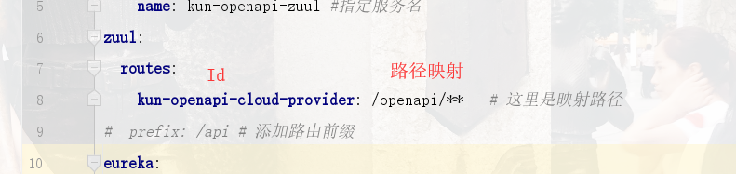

## [Zuul整合Swagger，使用ZuulFilter解决下游服务context-path](https://www.cnblogs.com/dalaoyang/p/12005283.html)

https://www.cnblogs.com/dalaoyang/p/12005283.html

